**Experiment No : 9**

**Name : Rajashri Jaywant Patil**

**Div : C Roll No : 44**

**Date :**

**Title : Write a Program using Array.**

**A] Index Array :**

<?php

$season = array("summer","Winter","Spring","autumn");

echo"Season Are: $season[0],$season[1],$season[2],$season[3]";

?>

**Output :**

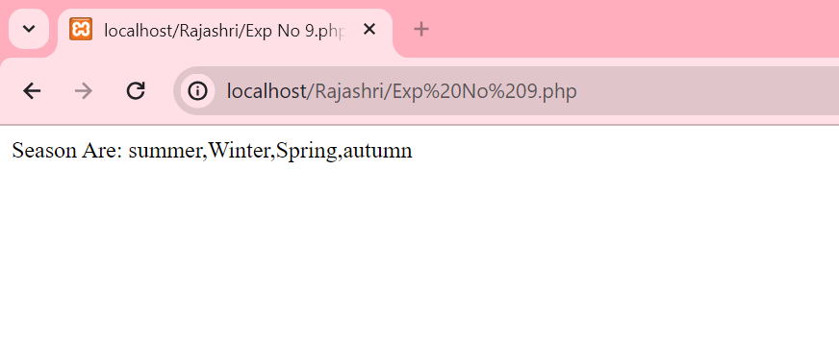

**B] Associative Array :**

<?php

$salary = array("Rajashri"=>"50000","Revati"=>"40000","Anuja"=>"30000","Pranali"=>"20000");

echo"Rajashri Salary :".$salary["Rajashri"]."<br/>";

echo"Revati Salary :".$salary["Revati"]."<br/>";

echo"Anuja Salary :".$salary["Anuja"]."<br/>";

echo"Pranali Salary :".$salary["Pranali"]."<br/>";

?>

**Output :**

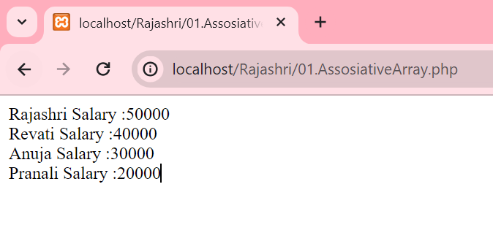

**C] Multidimensional Array :**

<?php

$emp = array

(

array(1,"Rajashri",50000),

array(2,"Revati",40000),

array(3,"Anuja",30000),

array(4,"Pranali",20000),

);

for($row = 0;$row<3;$row++) {

for($col = 0;$col<3;$col++) {

echo $emp[$row][$col]."";

}

echo"<br/>";

}

?>

**Output :**

